VEX V5 Override: Session 3 - Scoring Test
Activity: Score a Pin and then spin the Toggle to red to score more points.
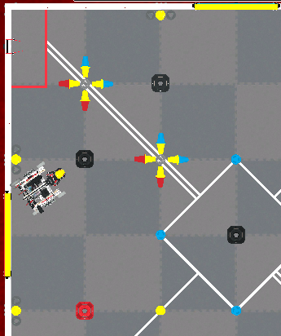
- Set up for the activity:
  - Make sure the Controller is paired with the robot. Use the information in this article to help you.
  - Set up your field as shown in the image to the right.
  - Start the Drive program on the VEX V5 Brain.
    - Control Flex’s arm and roller using the R buttons.
    - Open and close Flex’s claw using the Y and A buttons.
- You will test all four configurations and see how long it takes to score a Pin in a Neutral Goal and then spin the Toggle to red to score more points.
  - Time how long it takes to complete the drive path.
  - Record your time and any other notes about the task in your engineering notebook.
- Place Flex back into the same starting position with the Pin preloaded and the Toggle set to yellow. Repeat the test with each of the controller configurations.
  - Record the time and notes for each controller configuration.
Example Documentation: On the following page.
Remember, this is just one way to document your data. Document in the way that works best for you!

Feeling Stuck? Slow down and practice controlling Flex’s arm, claw, and roller before beginning the task.

Discussion Questions  - What do you like about each configuration?  - What do you dislike?  - Which of the four drive modes makes the arm, claw, and roller the easiest to control?  - How can you improve your driving or documentation skills? | Activity Checklist  - Each team member scored the Pin and flipped the Toggle to red with all four configurations.  - Each team member recorded drive data in the engineering notebook.

Example Documentation

Remember, this is just one way to document your data. Document in the way that works best for you!
Task: Score a Pin and then spin the Toggle to red to score more points.

Driver | Configuration | Joystick Controls | Time
Lauren | Dual  (Tank Drive) | 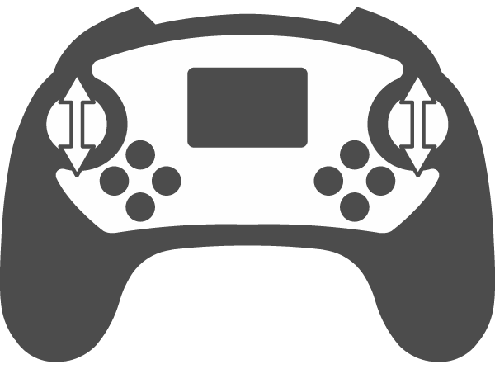  Left motor with left joystick  Right motor with right joystick | 36 seconds
Lauren | Notes:
Lauren | Left Arcade
Lauren | Notes:
Lauren | Right Arcade
Lauren | Notes:
Lauren | Split Arcade
Lauren | Notes:

